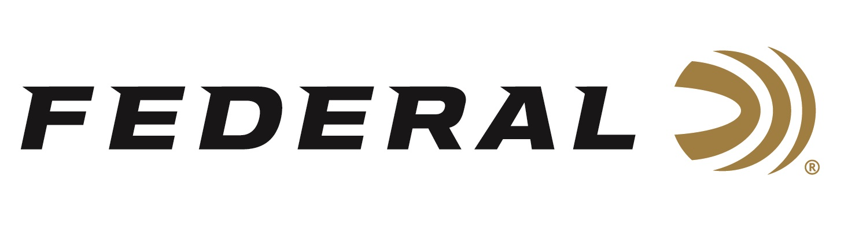

FOR IMMEDIATE RELEASE

Federal Ammunition is the Official Ammunition of ACUI Clay Targets Program

ANOKA, Minnesota – November 22, 2019 – Federal Ammunition expands its leadership position in supporting and sponsoring youth education and the shooting sports with the Official Ammunition designation within the ACUI Collegiate Clay Targets Program.

“Supporting the collegiate clay target programs through ACUI is an incredible opportunity for Federal. Being a part of the growing clay target sports at such a high level is near and dear to me and our company heritage,” said Jason Vanderbrink, President of Federal.

In addition to the designation of the Official Ammunition of the program, Federal will be the exclusive ammunition of the ACUI Collegiate Clay Target Championships. In 2019, the championships were host to nearly 900 collegiate athletes from 89 teams. This national championship has a storied tradition as it was first held in 1968 and has seen growth in participation as well as prestige over the last 50 plus years.

The ACUI Clay Target program is a nonprofit, student-centered, campus-based community for student athletes and those involved in coaching and promoting the programs. The ACUI community provides a foundation for student development, leadership opportunities, and personal growth through involvement in the shooting sports.

Learn more at Federal and all its ammunition products visit: www.federalpremium.com.

Press Release Contact: JJ Reich
Senior Press Relations Manager
E-mail: VistaPressroom@VistaOutdoor.com

About Federal Ammunition
Federal, headquartered in Anoka, MN, is a brand of Vista Outdoor Inc., an outdoor sports and recreation company. From humble beginnings nestled among the lakes and woods of Minnesota, Federal Ammunition has evolved into one of the world's largest producers of sporting ammunition. Beginning in 1922, founding president, Charles L. Horn, paved the way for our success. Today, Federal carries on Horn's vision for quality products and service with the next generation of outdoorsmen and women. We maintain our position as experts in the science of ammunition production. Every day we manufacture products to enhance our customers' shooting experience while partnering with the conservation organizations that protect and support our outdoor heritage. We offer thousands of options in our Federal Premium and Federal® lines-it's what makes us the most complete ammunition company in the business and provides our customers with a choice no matter their pursuit.

